Appendix 5

Test results for running 50,000 time steps with a public goods decay rate of 0.001

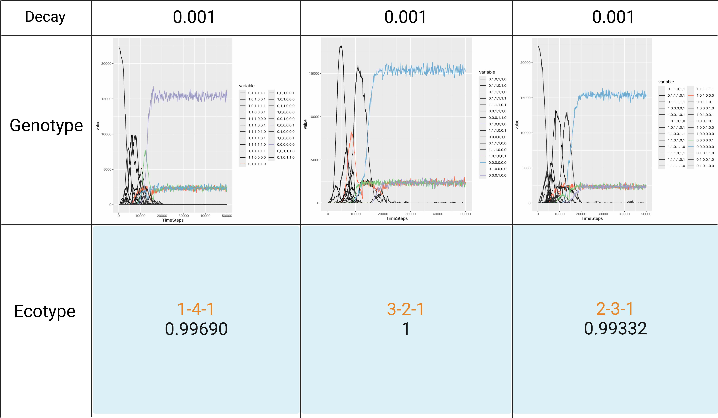
The genotype changes when the public goods decay rate is 0.001, and the ecotype composition at the 50,000th time step. The other parameters are "cost = 0.01", "public goods production interval = 1", "public goods diffusion interval = 1" and “Margolus Diffusion = 1”. The removal threshold for the number of genotypes were genotypes with a proportion less than 1. The content in the second line of the ecotype section represents the proportion of public goods produced by that ecotype composition within the community. Under the aforementioned parameter combinations, the community can continuously form division of labor within 50,000 time steps and continue to evolve toward Strong Black Queen dynamics. The dominant ecotypes of producers within the community are capable of producing all types of public goods, and the proportion of public goods they produce accounts for over 99% of the total in the community. This proves that when secreted metabolites serve as public goods, a public goods decay rate of 0.001 is sufficient to regulate the formation of division of labor among microorganisms within the community.

